* Under SKU column, remove the # symbol and * symbols in sku names from all skus. MPCat database does not support this symbol. Example ADD#300 will convert to ADD300 and **SVOG-PACK2A-FACH will convert to SVOG-PACK2A-FACH.
* For items with Category1, value = Upholstery, these items belong to “Parker Living” brand. In referencing the catalogs, we currently have, we do maintain two separate catalogs, one for Parker House and one for Parker Living. I no longer see the reference on the website to split these out, but in doing some research, it does appear that Parker Living is still an active line. We should be able to identify these items based on the Category of “Upholstery.” Would it be possible to create two files, one for Parker House branded items and one for Parker Living? If not, we can parse out on this end if needed.
* Remove symbols in file, example â€Ž [Leather](https://revalize.sharepoint.com/:x:/s/ContentTeam/EfdV1m9rWJtJti6s_SP-T6UB5_p9G25B3T3KfhJQGBwsVg) Reclining under Category2 column.
* Move content in column AF Material to column CU “Additional Information”.
* Move content in column AX Features1 to column CR “Construction”.
* Under Width, Depth and Height, remove (in.) example 128 in. should be 128
* Remove content in column CO Description. Will need to pull description from item page, see below examples below. “American Modern” is the Collection Name - “Cotten” is the cover name and “Cocktail Table” would be the item’s short Description.

Swivel Club Chair would be the short Description for the below item, if you cannot pull description only. We can potentially add the entire line of text to the Description column. Hope this makes sense. 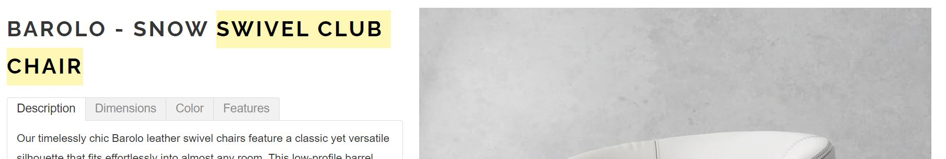

* In where image is not available, can you apply the value “Limited” under View Type column CH.